|  |  |  |
| --- | --- | --- |
| User manual for SSL keystore | January 4  2019 | |
| Steps required to prepare proper keystore for Jboss | | rupesh@virtualdoxx.com |



VirtualDoxx

Contents

1. Create keystore , keypair and csr on linux server. 1

2. Copy csr text and visit godaddy website 2

3. This zip file has leaf.crt 5

4. Now download root and intermediate certificates from repository of godaddy 6

5. Put all certificates in one folder 7

6. Return to putty and run import commands 7

7. Now check keystore in keystore explorer 8

8. Now copy keystore to server 9

9. Now reboot server 9

10. The End 9

## Create keystore , keypair and csr on linux server.

Note: csr is platform dependent.

*Password in below command is vdoxx999*

root@www6b:/home/rupesh/certificate-generation-install# keytool -keysize 2048 -genkey -alias vdoxx -keyalg RSA -keystore vdoxx.keystore

Enter keystore password:

Re-enter new password:

What is your first and last name?

[Unknown]: *.virtualdoxx.com

What is the name of your organizational unit?

[Unknown]:

What is the name of your organization?

[Unknown]: virtualdoxx

What is the name of your City or Locality?

[Unknown]:

What is the name of your State or Province?

[Unknown]: NC

What is the two-letter country code for this unit?

[Unknown]: US

Is CN=*.virtualdoxx.com, OU=Unknown, O=virtualdoxx, L=Unknown, ST=NC, C=US correct?

[no]: Yes

Enter key password for <vdoxx>

(RETURN if same as keystore password):

root@www6b:/home/rupesh/certificate-generation-install# keytool -certreq -keyalg RSA -alias vdoxx -file vdoxx.csr -keystore vdoxx.keystore

Enter keystore password:

You have new mail in /var/mail/root

root@www6b:/home/rupesh/certificate-generation-install# ls

vdoxx.csr vdoxx.keystore

## Copy csr text and visit godaddy website

Take back up of vdoxx.keystore now as vdoxx-after-csr.keystore

root@www6b:/home/rupesh/certificate-generation-install# cat vdoxx.csr

-----BEGIN NEW CERTIFICATE REQUEST-----

MIIC5TCCAc0CAQAwcDELMAkGA1UEBhMCVVMxCzAJBgNVBAgTAk5DMRAwDgYDVQQHEwdVbmtub3du

MRQwEgYDVQQKEwt2aXJ0dWFsZG94eDEQMA4GA1UECxMHVW5rbm93bjEaMBgGA1UEAwwRKi52aXJ0

dWFsZG94eC5jb20wggEiMA0GCSqGSIb3DQEBAQUAA4IBDwAwggEKAoIBAQC7RvaGoxyv7XU4YfOz

EzEL+OD72kzeTOeNMdosOb6RgPkUMBqwrDygi7B+HPhEs//mUP+7bY15D+tx00vfhGeGjlft9c5R

G5shFIj6h2fJJw1ou2NrzjVC4EaDwBlGtjJU34svZgYBW6gFjA36kxjJG+XA6TnxGs69fbr6HtZo

8woNPo/OcW95Ntq/kNqLiIv8tCFxUwKZpJ5V1Xxb+i7mzfgPzLqcrb31uhM2kptItIh58UQilhU9

1w72qN8h+tKGntmYZW0CrWuAYh41SJWH/tjYjVogsrWXDXofXzrTkw9NTPiyDDrKZRGNuGw2zkK8

8NdeYXTHmKVRA8o3IaF/AgMBAAGgMDAuBgkqhkiG9w0BCQ4xITAfMB0GA1UdDgQWBBSu00NB+Ucx

+ek0WagcfALXqPGSezANBgkqhkiG9w0BAQsFAAOCAQEAqa5B9NImGUfSMxQni+bjLULjMqrZfDpi

9a4QwnWQUvy4XE+kUtSXQtYSIKxzMblCiExTL0sO4KDWv09B+Oxb9JTG9y5HbI7MMU5LYtI0E+SY

EbFr+X21hLVbv1/g0oTDztaq6z+0qof0kBrZHxYbbj5BCH2Y7Bwbez/LKiLtaDdsEAHkY6nnnkn0

XkyPvjXVo05/f+GtLjt0Xz+T84wbZVMoNWxiDYAl4xDTxHDVTmvhuuXyGGWKHMs53PprTfLrLa1n

OIkL66ZfCH/k1Ik+nkP/AaV9QUPQtwlHIPZSO/JpqvtifGIwsYkM/BpfqohXywKsJz9v7UQN5Ukn

YhCWSQ==

-----END NEW CERTIFICATE REQUEST-----

root@www6b:/home/rupesh/certificate-generation-install#

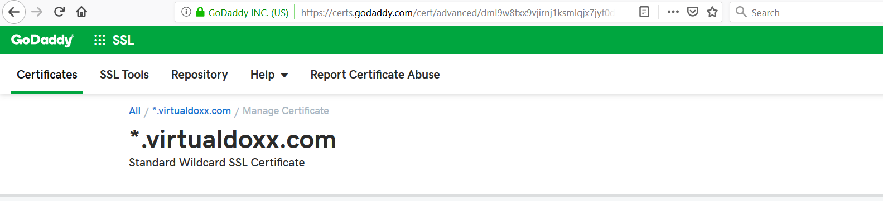

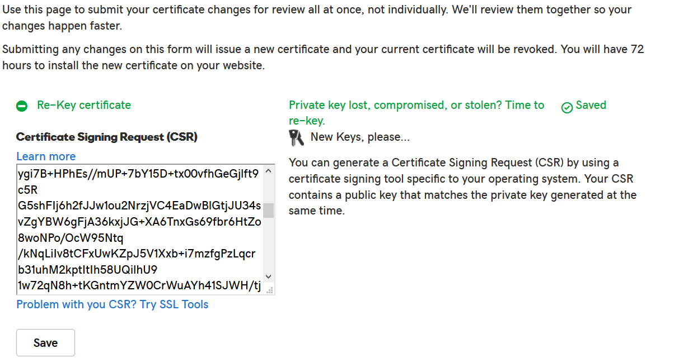

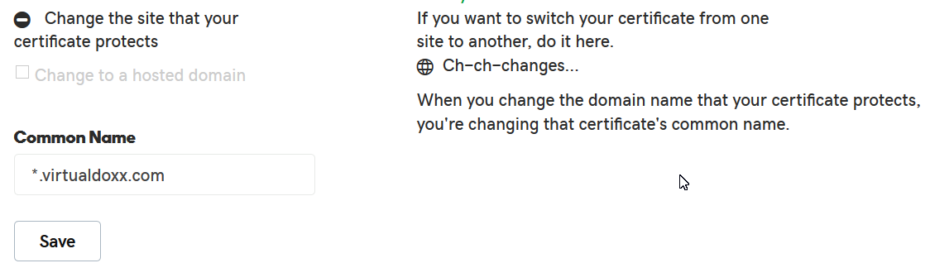

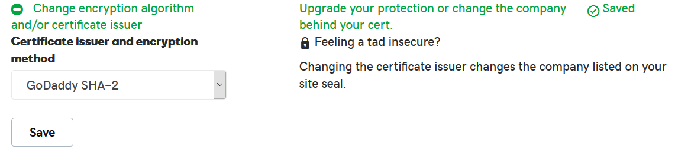

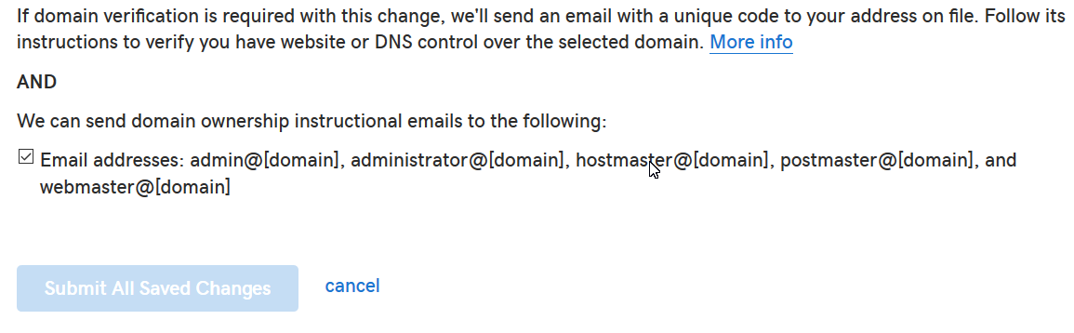

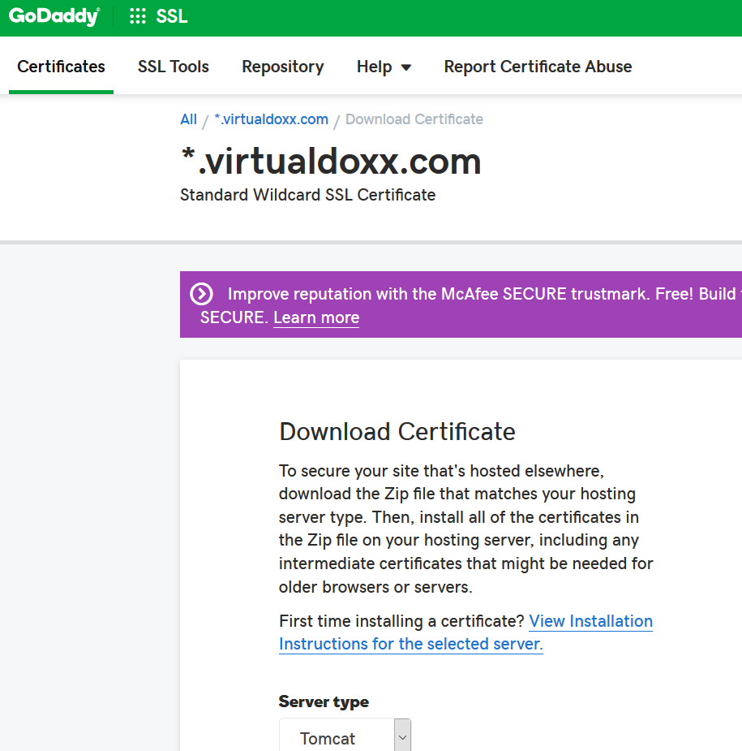

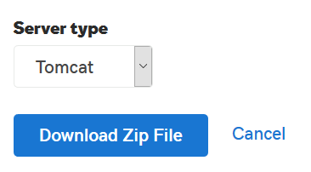

## This zip file has leaf.crt

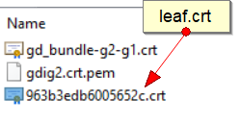

## Now download root and intermediate certificates from repository of godaddy

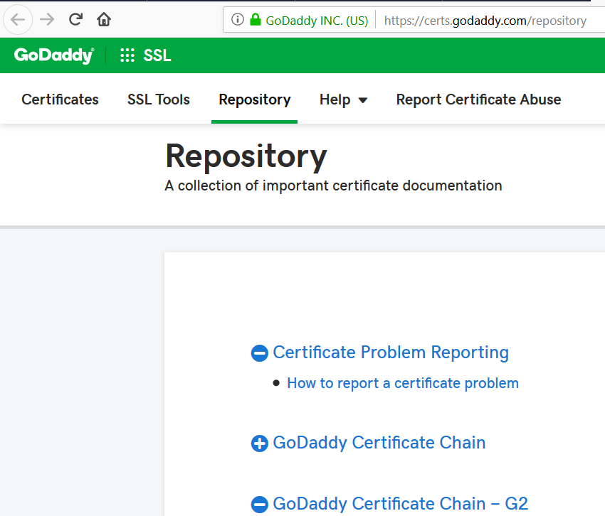

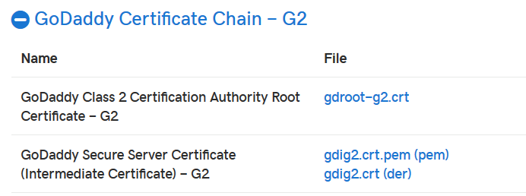

## Put all certificates in one folder

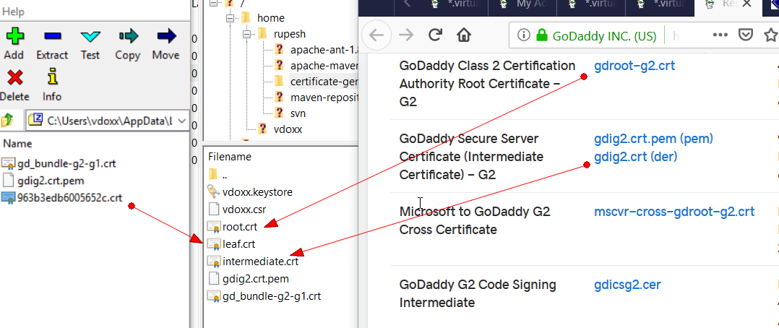

## Return to putty and run import commands

*root@www6b:/home/rupesh/certificate-generation-install# keytool -import -trustcacerts -alias root -file root.cer -keystore vdoxx.keystore*

*Enter keystore password:*

*[1]+ Stopped keytool -import -trustcacerts -alias root -file root.cer -keystore vdoxx.keystore*

*You have new mail in /var/mail/root*

*root@www6b:/home/rupesh/certificate-generation-install# keytool -import -trustcacerts -alias root -file root.crt -keystore vdoxx.keystore*

*Enter keystore password:*

*Keystore password is too short - must be at least 6 characters*

*Enter keystore password:*

*Certificate already exists in system-wide CA keystore under alias <godaddyrootg2ca>*

*Do you still want to add it to your own keystore? [no]: yes*

*Certificate was added to keystore*

*root@www6b:/home/rupesh/certificate-generation-install# keytool -import -trustcacerts -alias intermediate -file intermediate.crt -keystore vdoxx.keystore*

*Enter keystore password:*

*Certificate was added to keystore*

*root@www6b:/home/rupesh/certificate-generation-install# keytool -import -trustcacerts -alias vdoxx -file leaf.crt -keystore vdoxx.keystore*

*Enter keystore password:*

*Certificate reply was installed in keystore*

*You have new mail in /var/mail/root*

*root@www6b:/home/rupesh/certificate-generation-install#*

## Now check keystore in keystore explorer

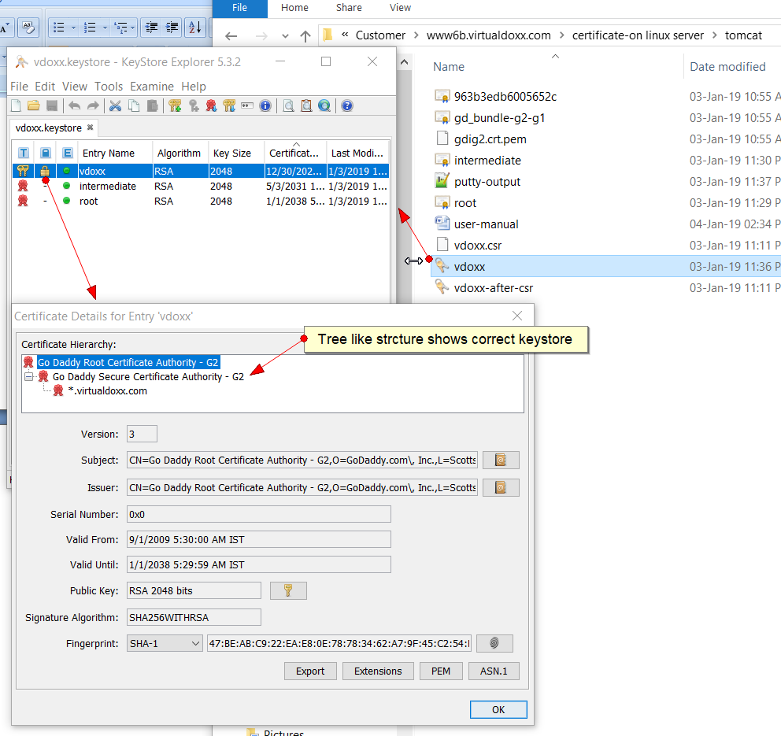

## Now copy keystore to server

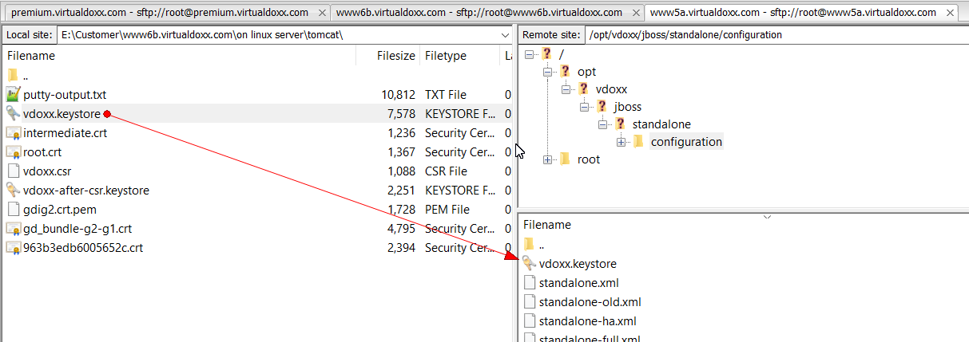

## Now reboot server

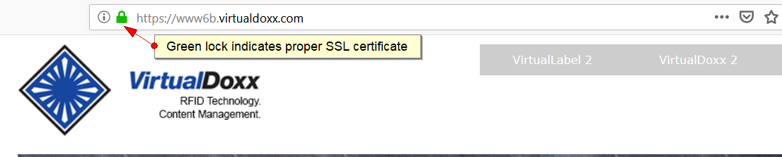

## The End